2012-2013 Board Meeting Agenda
Saturday, September 8, 2012 | 11 am
LA County Fair, Pomona
- Action Items from prior meeting
  - Grace
    - Setting up Paypal account, double check with Armando about food, seeing if CAYP branded items or Kiwanis tie can be used as prizes, contact Camille about decorations for banquet, figure out information for Rose Float Volunteer lunch
  - Camille will help out with decorations
  - Unsure if we can get T-shirts on time but maybe we can get a voucher so members can redeem a shirt later
  - Grace will connect calendar to CAYP secretary and treasurer account
  - Nina
    - Contact members re: dues, look up California Science Center for Nov. social, look up ice skating rinks for Dec. social, create monthly text reminders for socials, service projects, etc. at beginning of month, create “donations list” for socials after charity chosen
  - Grace will check if November 17th will interfere with Kiwanis Fall Rally
  - Still doing California Science Center for November social; Nina will check out ticket costs
  - Nina will connect roster to Google Docs
  - Natalie
    - Check in with DJ Torado, talk to Lois about service project with Good Shepherd Shelter and LACES, setting up small service project for ASD-talk with Brenda, coordinating small service project for Banquet, figure out dates for CKI South and check with J.Cao Nguyen if we can be judges, find a charity that would like to receive donations
  - Natalie checked in with DJ but DJ said he still needs to pay; waiting until the new year will start
  - Natalie is waiting to hear back from Good Shepherd Shelter and ASD
  - J-Cao said we need to talk with Camille and Hans if we want to be judges
  - Adrian
    - Contacting friends to be dealers for Casino night, brainstorm raffle prizes for banquet, support Grace, Natalie, and Nina with various tasks
  - Kim
    - Plan decorations for banquet (Casino theme); ex: centerpieces, etc., brainstorm raffle prizes for banquet, support Grace, Natalie, and Nina with various tasks
  - Everyone
    - Find 1 raffle prize for Casino theme, create “Tie trophy” for Best Looking Tie Contest
- Membership
  - Member survey - current results
  - Plan on printing out surveys or having a laptop available during banquet
  - New Members - Luke Liao
  - Luke and DJ are both approved
- LACES KIWIN'S
  - Fall Rally and Rose Float decorating
- Recommended contacting people directly for Rose Float Volunteer lunch since division isn’t too strong
- Grace will check out dates for Fall Rally and Rose Float
- Upcoming and Past Events
  - Banquet – 5th year anniversary! Sat, 10/20|Bellflower Kiwanis Hall [9302 Laurel Ave, 90706]
    - Service project – Natalie
  - Contacting ASD or Good Shepherd Shelter; Natalie will let Grace know if supplies are needed
    - Casino Night and Entertainment – Adrian
      - Casino items from Peter; board games from Nina and Adrian
      - Dealers?
    - Raffle - 8 prizes (2 Starbucks GC, etc.) can be surprise if we keep it in themed box
  - Having mystery raffle prizes and decorate and wrap them; Nina has cardboard boxes that we can decorate
    - PowerPoint presentation chronicling the past 5 years - V.K.
    - Advertisement - Nina
      - CAYP members, Kiwanis clubs in Division 1, Circle K members
      - Emailing members with Banquet Flyers
      - Grace will try to find a flyer template for banquet
      - Nina will invite other Kiwanis clubs
      - Natalie will invite other Circle K clubs (LTGs of Metro and Magic Kingdom)
    - Food – Mexican food from Mondo's restaurant
    - Pricing: $10 members, $15 nonmembers, $6 for volunteers
    - Other items
  - Need Projector for banquet – Nina said she has a banquet
  - Grace needs bell, gavel and banner from VK
    - THEME – Casino theme with tie contest
      - Member with best tie will receive a special prize (Ex: Kiwanis tie or gift card)
      - Decorations –centerpiece with poker chips, deck of cards, rose petals, etc.; Camille is looking at decorations for us
    - DEADLINES
  - Grace will get flyers by the end of this week
  - Roster will be put together by this weekend; Natalie will input the roster on the Kiwanis database ASAP
  - Natalie will grant access to Nina/Grace for KiwanisOne
  - Nina will buy the domain for CAYPkiwanis.org
  - Service projects
    - September event
    - October – Children's Institute with Zully?
      - CKI South –CAYP members judges for the event?
    - November – LA Food Bank, Soup Kitchen, Rescue Mission
    - December – Rose Float Volunteer Lunch
  - Fundraising and Socials
    - September 8 – LA County Fair
    - October 20 – Banquet
    - November 10 – Museum social at Calif Science Center
  - Nina will check group discounts
    - December 8 – Ice Skating social in Pasadena
    - March –March Madness
    - May – Mulligan's
  - Nina still needs info for Mulligans
    - Donation requirement for non-members who want to attend our socials. Natalie to identify charity to receive donations and see what items they might need; CKI members are not required to donate items if they attend socials
  - Natalie is still in the process of choosing a social
  - Other Events
    - CAYP Info Session- Sat 9/22 1 pm Bellflower Kiwanis Hall
    - Circle K Metro Trainer - Sat 9/29 USC campus
  - Grace said they are looking for Workshop hosts
  - Grace will send out list of workshops that still need to be hosted
    - South Gate ‘Career and Education Resource Fair’ for young adults - Sat 10/6, 10am-2pm
      - Looking for YP adults in different professions to host booths and offer insights to their professions and possible openings
      - Application due 9/15 (meetings to attend-Mondo volunteered)
    - Children's Institute
      - Halloween Festival 10/27 11am-2pm: operating games, crafts, read stories, etc
    - Grace will confirm that we can attend this event
      - Superstart – requires orientation and multiple days
      - Stories Abroad – requires orientation and multiple days
    - Divisional Budget - attached in email, send feedback by Oct. 15
  - LTG Ted wants to know if adjustments to budget need to be made
    - Danny and Mondo are hosting a CAYP info session
- Announcements and Open Forum
- NEXT BOARD MEETING – October 20, 2012 before banquet

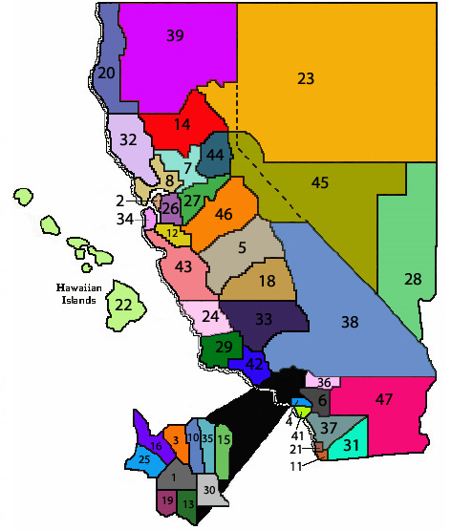
KIWANIS FUN FACT: We are in Division 1 of Kiwanis, which by #, is the first division of Kiwanis to be formed. Division 2 is up north, near Oakland.

