2012-2013 Board Meeting Agenda
Saturday, August 18, 2012 | 12:30 pm
Porto's Bakery & Cafe, Downey
- Membership
  - Member survey - what they’re looking for, what they want to accomplish with CAYP
    - Current results (and end date)
7 responses on survey – 3 board members, 1 CKI member, 3 non-board member
  - New members
-Prospective new members – Lea from Carson & DJ Torado from UCI (Natalie will check in)
-Nina: collecting membership dues (check); revamping Paypal account
- LACES KIWIN'S
- August 4th (past board meeting): Grace and VK spoke with LACES Kiwins advisor; hoping to involve CAYP Kiwanis more and helping out with Fall Rally, District Convention, and Rose Float Parade
-Setting up possible project with Good Shepherd Shelter and LACES Kiwins (Natalie will talk to Lois)
- Upcoming and Past Events
  - Banquet – 5th year anniversary!
    - Date and Location - Saturday, October 20 at Bellflower Kiwanis Hall – Grace
      - People can start arriving at 5PM
    - Service project - Natalie
      - For ASD, Good Shepherd Shelter, or PYHO – Still in the process of deciding who to make the service project for
    - Casino Night – Adrian
      - Peter and Nina for Materials – getting poker chips from Peter
      - Board Games – Jenga and Taboo (Nina)
      - Adrian has friends who can be dealers
    - Raffle
      - Finding prizes – Getting 8 prizes total; Grace has random prizes; Each member will try to bring a raffle prize; Will see if CAYP branded items are available
    - PowerPoint presentation chronicling the past 5 years - V.K.
    - Advertisement - Nina
      - CAYP members
      - Other Kiwanis clubs in Division 1
      - Circle K members
    - Food – Contacting Armando
      - Mexican Food
    - THEME – Casino theme with tie contest
      - Each person will wear a tie; the member with the best tie will receive a special prize (Ex: Kiwanis tie or gift card)
      - Decorations – creating a centerpiece with poker chips, deck of cards, rose petals, etc. ; Camille Goulet has possible decorations
    - DEADLINES
      - Location/Date by mid-August DONE
      - Contacting V.K., Armando, and Peter
  - Service projects
    - August 18 – Gardena Willows Wetland Preserve
    - August 25/26 – Fiesta La Ballona
      - Grace, Natalie, and VK said they may be able to attend the service project
    - September event – setting up service project with ASD (depends if CAYP can do projects with Children’s institute)
    - October – Children's Institute with Zully?
      - CKI South – Natalie will contact J. Cao Nguyen to see if CAYP members can be judges for the event
    - November – LA Food Bank, Soup Kitchen, Rescue Mission
    - December – Rose Float Volunteer Lunch: yay or nay? – yay; we will be volunteering and invite LACES Kiwins to volunteer on the same day
  - Fundraising and Socials
    - September 8– LA County Fair
      - Still need to figure out location of meeting
      - Board meeting at 11AM
      - General Meeting at 12PM
    - October – Banquet
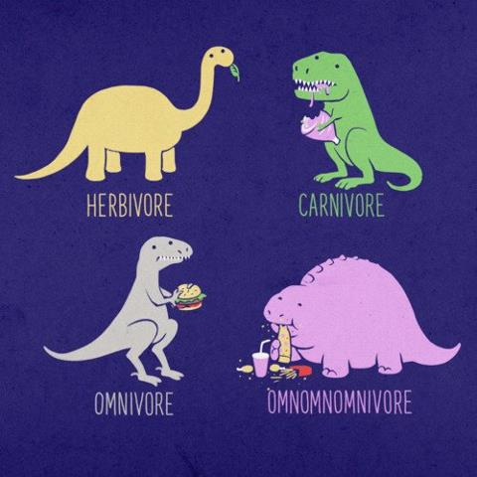
    - March –March Madness
    - May – Mulligan's
    - For socials, Nina suggested creating a donation requirement for non-members who want to attend our socials. Natalie will identify a charity that we can donate items to and also see what items they might need; CKI members are not required to donate items if they attend socials because they are part of the Kiwanis Family
- Announcements and Open Forum
  - Nina recommended updating the website with board member bios and even general member bios
- ACTION ITEMS
- Grace
  - Check in with Lea (sp?) from Carson
  - Setting up Paypal account
  - Double check with Armando about food
  - Seeing if CAYP branded items or Kiwanis tie can be used as prizes
  - Contact Camille about decorations for banquet
  - Figure out information for Rose Float Volunteer lunch
- Nina
  - Will contact members about paying dues
  - Look up California Science Center for November Social (http://www.californiasciencecenter.org/)
  - Look up ice skating rinks for December Social
  - Creating monthly text reminders for socials, service projects, etc. at the beginning of the month
  - Creating “donations list” for socials after Natalie chooses charity
- Natalie
  - Check in with DJ Torado
  - Will talk to Lois about setting up a service project with Good Shepherd Shelter and LACES
  - Setting up small service project for ASD; talking with Brenda
  - Coordinating small service project for Banquet
  - Check with Culver City Kiwanis if they need our help service pancakes
  - Figure out dates for CKI South and check with J.Cao Nguyen if we can be judges
  - Find a charity that would like to receive donations
- Adrian
  - Contacting friends to be dealers for Casino night
  - Brainstorm raffle prizes for banquet
  - Support Grace, Natalie, and Nina with various tasks
- Kim
  - Plan decorations for banquet (Casino theme); ex: centerpieces, etc.
  - Brainstorm raffle prizes for banquet
  - Support Grace, Natalie, and Nina with various tasks
- Everyone
  - Finding 1 raffle prize for Casino theme
  - Creating “Tie trophy” for Best Looking Tie Contest

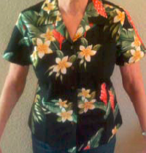
- NEXT BOARD MEETING – September 8, 2012
KIWANIS FUN FACT: Our district shirt is always a Hawaiian shirt. Perhaps a nod to Hawaii being in our district.

